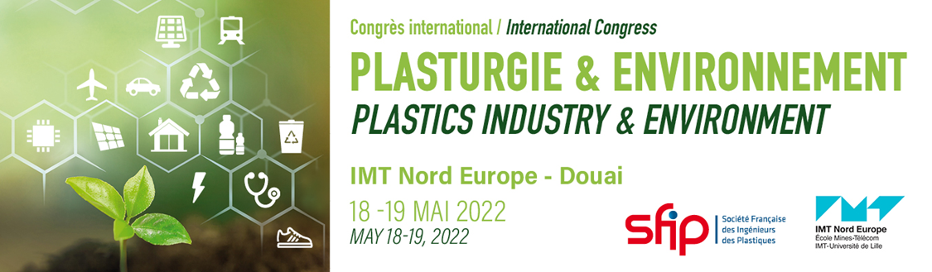

PRESS RELEASE
Paris-Douai, March 10, 2022

SFIP - IMT Nord Europe International Congress« PLASTICS INDUSTRY & ENVIRONMENT »
May 18-19, 2022 - Douai, France

SFIP – the French Society of Plastics Engineers - and IMT Nord Europe – an engineering graduate school of the Institut Mines-Télécom – announce the launch of a new congress entirely dedicated to the environment!
A plastics industry’s key event
Organised on 18 and 19 May 2022 on the Douai campus of IMT Nord Europe with the support of the French polymer converters' union, POLYVIA, the competitiveness cluster, POLYMERIS, and the leading European trade association, Plastics Europe, this cross-sectoral congress will address issues related to circular economy and eco-responsibility in the plastics and composites industry. "These environmental aspects can no longer be ignored and must be taken into account in the development of industrial parts made of plastic and composite materials" comments Gérard Liraut, President of SFIP.
Conferences, panel discussion, exhibition: testimonials from key European players
Aspects related to decarbonising and life cycle analysis, recycling technologies, waste treatment methods, alternatives to oil with bio-based solutions will be addressed through different sessions. Visions and approaches implemented by different markets will also be illustrated with concrete examples shedding light on the strategies adopted in the automotive, sports, construction, packaging, textile and electrical/electronic equipment sectors. Common issues will be highlighted in order to reduce the environmental footprint: eco-design, development of new high-performance and sustainable materials, recyclability, etc.
A panel discussion will present the plastics producers viewpoint: what are their strategies to reduce their environmental footprint, what type of recycling to implement, how to increase the quality (performance, functionality, durability) of their products and what are their ambitions in terms of sustainable development?
In addition to the conferences, an exhibition area will allow to pursue the exchanges and to discover the portfolios of services, materials and products of the exhibiting companies.

Targeted audience
Offering a comprehensive overview of the strategies, solutions and ambitions of the plastics and composites industry struggling towards better circularity and sustainability, this congress positioned at the crossroads of plastics and the environment is intended to bring together all the key players in the sector: recyclers, compounders, producers of materials (plastics, additives, reinforcements, fillers, etc.), plastics converters and composites manufacturers, end users, contractors, eco-organisations, academia, etc.
Programme
Registration

About IMT Nord Europe
www.imt-nord-europe.fr
IMT Nord Europe is one of the largest engineering schools north of Paris, with 2,100 students, a quarter of whom are apprentices, over 600 graduates per year and a network of 15,000 graduates. It is part of the Institut Mines Télécom and is a partner of the University of Lille. Its mission is to train engineers who are useful to their country and ready for the world of tomorrow, mastering both digital technologies and industrial know-how. Ideally located at the crossroads of Europe, between Paris, London, Brussels and Amsterdam, IMT Nord Europe aims to become a key player in the major industrial and digital transformations of the 21st century, combining engineering sciences and digital technologies in its teaching and research.
About SFIP
www.sfip-plastic.org
The « Société Française des Ingénieurs des Plastiques » (SFIP) is a non-profit association created in 1983. It brings together and federates engineers, technicians and other professionals in the plastics industry in order to promote their professions and activities: production of raw materials, processing and manufacturing technologies, materials characterization, simulation and applications. SFIP has nearly 200 members from some thirty companies. A think tank, a knowledge hub, a place for exchanges, sharing and meetings... SFIP brings together the main professionals in the plastics industry and helps to promote the science and technology of plastics and composite materials. SFIP is managed by a board of about twenty members from industry or academia, and by an office of seven people.

Press contact
Pauline DESPORTES, SFIP, pauline.desportes@sfip-plastic.org

